|  |  |  |  |
| --- | --- | --- | --- |
| **Roll No: 113** | **Name: Harshita Shetty** | **Div: B** | **Batch: B2** |

**Experiment No.7: DBMS**

**Aim:** Develop an application that makes use of a Database.

**Theory:** DBMS stands for Database Management System, which is a software system that allows users to manage and manipulate large sets of data in a structured manner. DBMS is designed to store, retrieve, and manage data efficiently and securely while providing an interface for users to interact with the data.

A DBMS typically includes several components, including the data definition language (DDL), data manipulation language (DML), query language, data structures, and database security mechanisms.

The DDL allows users to create and modify the structure of the database, defining the tables, columns, indexes, and other attributes of the data. The DML provides a set of commands that allow users to add, delete, and modify data within the database.

The query language allows users to retrieve data from the database based on specific criteria, using SQL (Structured Query Language) or other query languages. The data structures within the DBMS are optimized for fast data retrieval, with mechanisms such as indexes and B-trees. Finally, database security mechanisms are used to ensure the privacy and security of the data within the database. This can include access controls, encryption, and backup and recovery mechanisms.

Overall, DBMS is a critical component of modern information systems, used in a wide range of applications, from finance and healthcare to retail and manufacturing. The effectiveness of DBMS in managing and manipulating large sets of data has greatly enhanced the efficiency and accuracy of information management, providing significant benefits to businesses and organizations.

**Program:**

# MainActivity.kt

/*

* Copyright (C) 2021 The Android Open Source Project.

*

* Licensed under the Apache License, Version 2.0 (the "License");
* you may not use this file except in compliance with the License.
* You may obtain a copy of the License at

*

* http://www.apache.org/licenses/LICENSE-2.0

*

* Unless required by applicable law or agreed to in writing, software
* distributed under the License is distributed on an "AS IS" BASIS,
* WITHOUT WARRANTIES OR CONDITIONS OF ANY KIND, either express or implied. * See the License for the specific language governing permissions and * limitations under the License.

*/

package com.example.inventory

import android.os.Bundle

import androidx.appcompat.app.AppCompatActivity import androidx.navigation.NavController import androidx.navigation.fragment.NavHostFragment

import androidx.navigation.ui.NavigationUI.setupActionBarWithNavController

class MainActivity : AppCompatActivity(R.layout.activity_main) {

private lateinit var navController: NavController

override fun onCreate(savedInstanceState: Bundle?) { super.onCreate(savedInstanceState)

// Retrieve NavController from the NavHostFragment val navHostFragment = supportFragmentManager

.findFragmentById(R.id.nav_host_fragment) as NavHostFragment navController = navHostFragment.navController // Set up the action bar for use with the NavController setupActionBarWithNavController(this, navController)

}

/**

* Handle navigation when the user chooses Up from the action bar.

*/

override fun onSupportNavigateUp(): Boolean {

return navController.navigateUp() || super.onSupportNavigateUp()

}

}

# ItemRoomDatabase.kt

/*

* Copyright (C) 2021 The Android Open Source Project.

*

* Licensed under the Apache License, Version 2.0 (the "License"); * you may not use this file except in compliance with the License.
* You may obtain a copy of the License at

*

* http://www.apache.org/licenses/LICENSE-2.0

*

* Unless required by applicable law or agreed to in writing, software
* distributed under the License is distributed on an "AS IS" BASIS,
* WITHOUT WARRANTIES OR CONDITIONS OF ANY KIND, either express or implied. * See the License for the specific language governing permissions and * limitations under the License.

*/

package com.example.inventory.data

import android.content.Context import androidx.room.Database import androidx.room.Room

import androidx.room.RoomDatabase

/**

* Database class with a singleton INSTANCE object.

*/

@Database(entities = [Item::class], version = 1, exportSchema = false) abstract class ItemRoomDatabase : RoomDatabase() {

abstract fun itemDao(): ItemDao

companion object {

@Volatile

private var INSTANCE: ItemRoomDatabase? = null

fun getDatabase(context: Context): ItemRoomDatabase {

// if the INSTANCE is not null, then return it,

// if it is, then create the database return INSTANCE ?: synchronized(this) { val instance = Room.databaseBuilder( context.applicationContext, ItemRoomDatabase::class.java,

"item_database"

)

// Wipes and rebuilds instead of migrating if no Migration object.

// Migration is not part of this codelab.

.fallbackToDestructiveMigration()

.build()

INSTANCE = instance // return instance instance

}

}

}

}

# Activity_main.xml

<?xml version="1.0" encoding="utf-8"?><!--

~ Copyright (C) 2021 The Android Open Source Project.

~

~ Licensed under the Apache License, Version 2.0 (the "License"); ~ you may not use this file except in compliance with the License.

~ You may obtain a copy of the License at

~

~ http://www.apache.org/licenses/LICENSE-2.0

~

~ Unless required by applicable law or agreed to in writing, software

~ distributed under the License is distributed on an "AS IS" BASIS,

~ WITHOUT WARRANTIES OR CONDITIONS OF ANY KIND, either express or implied. ~ See the License for the specific language governing permissions and ~ limitations under the License.

-->

<androidx.constraintlayout.widget.ConstraintLayout xmlns:android="http://schemas.android.com/apk/res/android" xmlns:app="http://schemas.android.com/apk/res-auto" xmlns:tools="http://schemas.android.com/tools" android:layout_width="match_parent" android:layout_height="match_parent" tools:context=".MainActivity">

<androidx.fragment.app.FragmentContainerView android:id="@+id/nav_host_fragment"

android:name="androidx.navigation.fragment.NavHostFragment"

android:layout_width="0dp" android:layout_height="0dp" app:defaultNavHost="true" app:layout_constraintBottom_toBottomOf="parent" app:layout_constraintLeft_toLeftOf="parent" app:layout_constraintRight_toRightOf="parent" app:layout_constraintTop_toTopOf="parent" app:navGraph="@navigation/nav_graph" />

</androidx.constraintlayout.widget.ConstraintLayout>

**Output:**

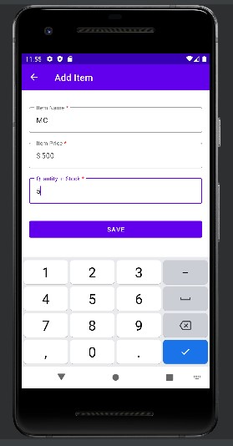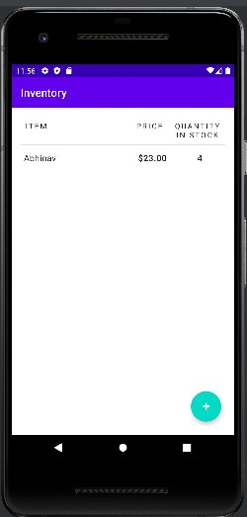

# GitHub Link: https://github.com/shettyharshita/Mobile-Computing

**Conclusion:** The experiment was about Database DBMS and the use of Database is to connect the data in database server which is successfully implemented and verified.